**Assignment 3**

1. **Sarsa Algorithm**

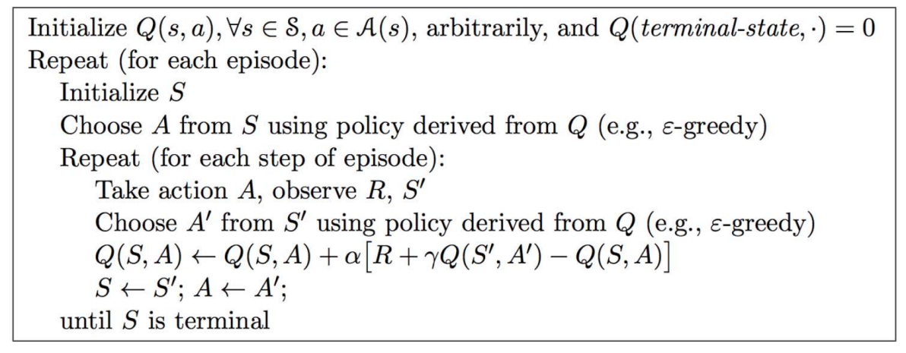

Sarsa algorithm is for on-policy learning. In each step, the agent would produce state S’ for next time according to A and S. And what’s different is that Sarsa would also produce the corresponding action A’ using greedy strategy. The greedy choose strategy is as follows:

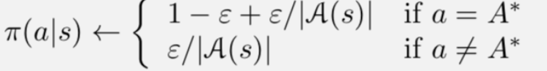

In my implementation, total time of iteration is 1000, $α=0.5,γ=1,ε=0./0.1/0.5$. Each iteration starts from [4, 0] and ends when reaching [4,12]. Reward for each step would be -1 unless:

1. stepping into cliff area R=-100, state returns to [4, 0].
2. Reaching terminal point [4,12], R=100.

$ε=0.5$, it choose the safe path.

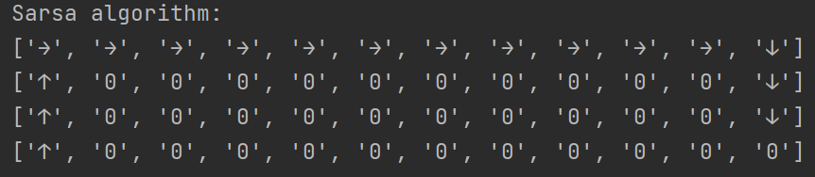

$ε=0.1$, it choose the path between safe and optimal.

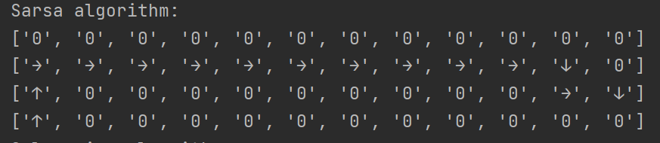

$ε=0$, it choose the optimal path.

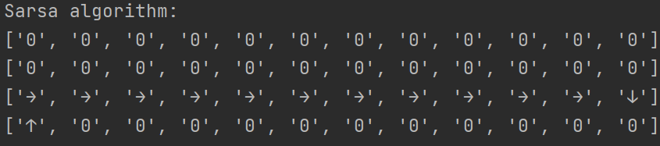

The smaller ε is, the possibility of choosing a none-optimal action is smaller, so sarsa is more likely to choose a optimal path. And with possibility of choosing none-optimal action, with fear of going into cliff area, it tends to choose a safer path.

1. **Q-Learning**

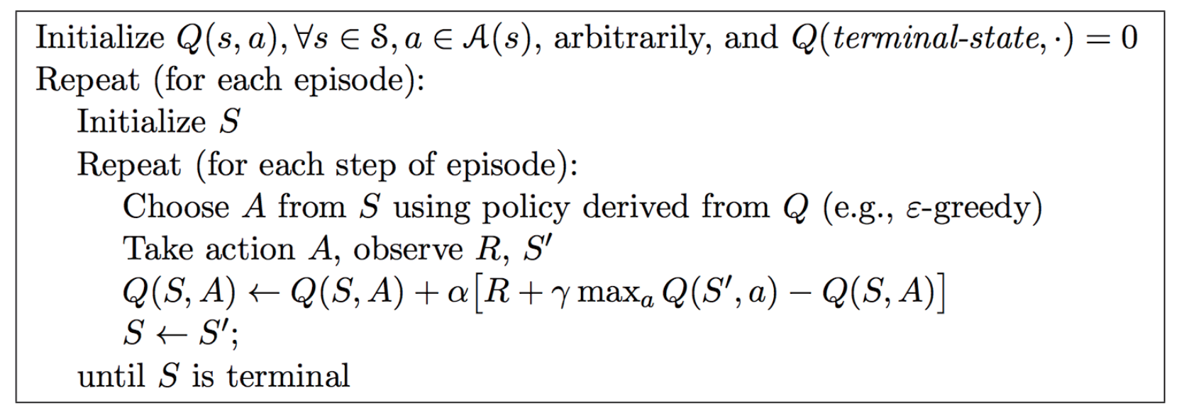

The difference between Q-learning and sarsa is the way of updating Q value. In Q-learning, greedy algorithm is used to choose an action and update Q-value while the real action to execute is still choosed by ε-greedy algorithm. In comparison, sarsa choose the same action in updating Q-value and execution, which determines by ε-greedy algorithm. Therefore, Q-learning is an off-policy algorithm.

With ε being 0, 0.1 and 0.5, the result remains the same. So Q-Learning would always choose the optimal path.

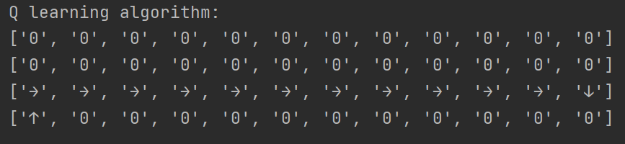

Because in Q-Learning, Q-value is always updated using the optimal choise. So ε could only determine the states in each episode, but has no effect on the policy.